**About SCP**

The BIG-IP Next SCP Cloud-Native Network Function (CNF) can be flexibly deployed on Kubernetes cloud-native infrastructure to give service providers a central point to secure and control signaling communication and monitor the health of the system.

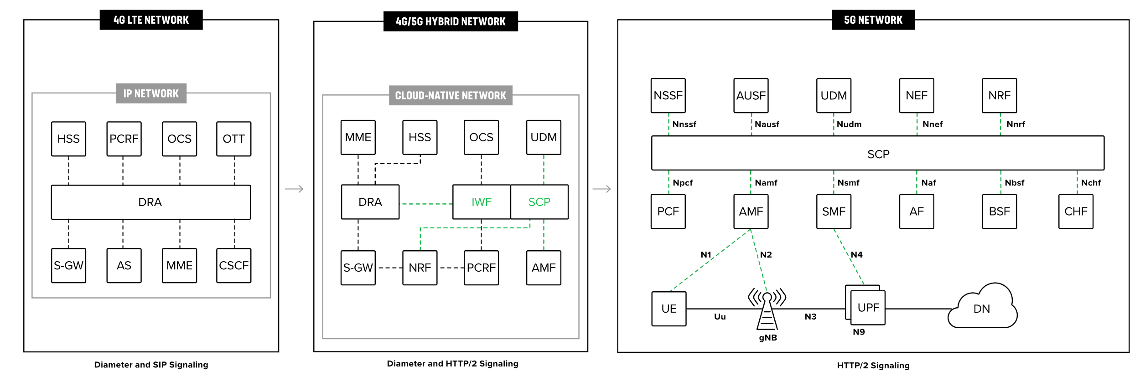

**Abbreviation**

F-SEID (Full Qualified Session Endpoint ID)

**SS lama**

Beberapa skrinsutan lama

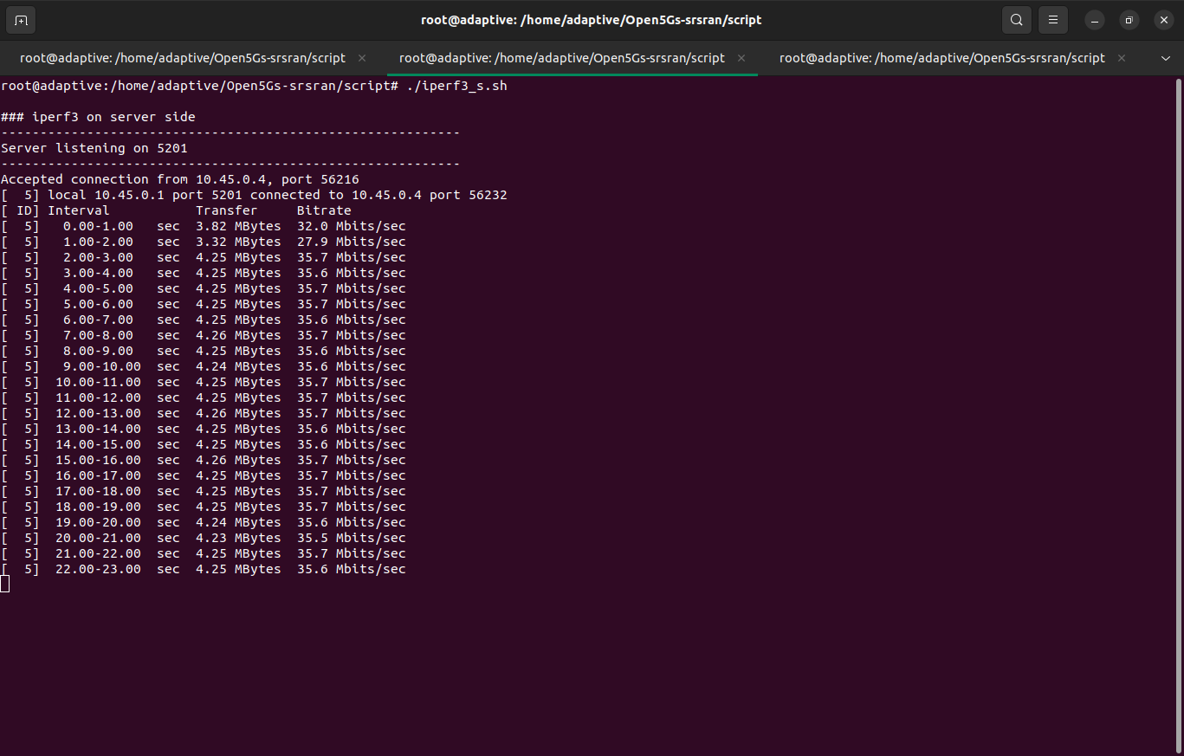

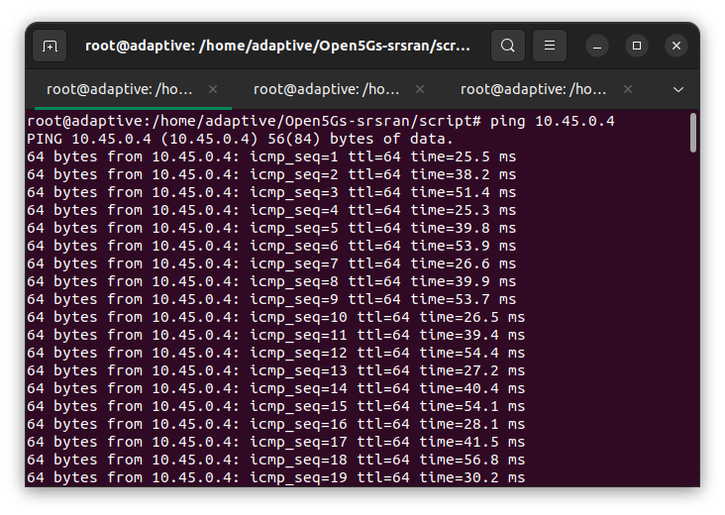

Bitrate tcp

32.0

27.9

35.7

35.6

35.7

35.7

35.6

35.7

35.6

35.6

35.7

35.7

35.7

35.6

35.6

35.7

35.7

35.7

35.7

35.6

35.5

35.6

35.7

35.6

35.6

35.6

Ping delay

25.5

38.2

51.4

25.3

39.8

53.9

26.6

39.9

53.7

26.5

39.4

54.4

27.2

40.4

54.1

28.1

41.5

56.8

30.2

38.8